

**US Army Corps of Engineers**

**Afghanistan Engineer District**

AED Design Requirements: Hydrology Studies

Various Locations, Afghanistan

FEBRUARY 2011

**TABLE OF CONTENTS**

AED DESIGN REQUIREMENTS FOR

HYDROLOGY STUDY VARIOUS LOCATIONS, AFGHANISTAN

**Section** Page

**1. General 1**

**2. Hydrology 1**

**3. Design Storm 1**

**4. Runoff Computation Methods 2**

**4.1. Rational Method 2**

**4.2. SCS Unit Hydrograph Method 10**

**5. Design Submittal Documentation 24**

**6. References 24**

**Tables**

Table 1. Runoff Coefficient Values 3

Table 2. Manning’s Channel Roughness Coefficient 9

Table 3. SCS Curve Number for Hydrologic Soil Groups 18

Table 4 Dimensionless Rainfall-Depth-Duration for Use in WinTR55 or WinTR20 22

**Figures**

Figure 1. Overland Flow Time of Concentration 6

Figure 2. Shallow Concentrated Flow Velocity 7

Figure 3. SCS Unit Hydrograph Results for 1 Sq Km 11

Figure 4. SCS Soil Classification for Soil Groups 12

Figure 5 Saturated Hydraulic Conductivity Based on Soil Properties 16

**Appendices**

Appendix A Example of Rational Method

Appendix B Intensity Duration Frequency Curves

Appendix C Area Factor for Point Rainfall Reduction Curves

Appendix D SCS Hydrograph Analysis Example

**1. General**

The purpose of this document is to illustrate the technical requirements contractors shall show in design analyses for projects requiring hydrology analysis of storm drainage components that are part of USACE-AED projects. The guidance is provisional – meaning it serves for the time being only until permanently replaced. The development of hydrologic statistics in Afghanistan is an ongoing process and as new data and analyses become available they will be incorporated into this design guide. A companion design guide discusses technical requirements for the design of culverts and road causeways - two hydraulic structures that require hydrologic analysis as the basis of the design.

**2. Hydrology**

Hydrology studies include a careful appraisal of factors affecting storm runoff to insure the development of a drainage system or road crossing culverts are capable of providing the required flow conveyance at the specified annual flood frequency of protection in the contract technical requirements. If the design flood frequency is not specified, the engineer shall base the selection of design storm magnitudes not only on the protection sought but also on the type of construction contemplated and the consequences of storms of greater magnitude than the design storm as specified in References 1 and 9.

Hydrologic studies for USACE-AED projects are generally concerned with the estimate of peak flow rates for use in the hydraulic design of channels, culverts, and erosion control and energy dissipation structures. In limited situations where ponding capacity is required, such as detention or infiltration facilities, runoff volume estimation is required. General USACE design information is provided in Reference 1.

Two hydrologic methods are preferred for use on USACE-AED projects: the Rational Method and the unit hydrograph method. The Rational Method shall be used when the catchment area draining to the structure or other point of concentration is less than one (1) square kilometer (247 acres). The Rational Method is generally limited to the calculation of the peak flow rate. The unit hydrograph method is required for drainage areas greater than one square kilometer. The theory and assumptions involved with these methods are well documented in design manuals and hydrologic engineering texts; two references which can be obtained from U.S. Government internet sources are included in References 2 and 3. The intent of this guide is to provide standardized data and assumptions in the use of these methods to simplify design and review of projects.

**3. Design Conditions**

Ground conditions affecting runoff must be selected to be consistent with existing and anticipated development and also with the characteristics and seasonal time of occurrence of the design rainfall.

Design conditions for the Rational Method consist of the runoff coefficient (C), the rainfall intensity-duration-frequency relationship, and the time of concentration. The runoff coefficient is a single parameter that considers soil type, land use cover (bare, vegetation, or pavement) and slope. There are several sources for C values that are acceptable provided they are accompanied by a complete reference in the design analysis. Generally the more information that is used in the C-value evaluation, the more accurate the flow estimation will be. A suggested chart is included in the next section that has compiled C values from several

references.

In the majority of areas such as military, industrial, and cantonment areas, the design storm will normally be based on rainfall of 10-year frequency. This is equivalent to an annual probability of being equaled or exceeded equal to ten percent each year (Probability=1/10= 0.1, or 10 percent expresses as a percent). Potential damage or operational requirements may warrant a more severe criterion which shall usually be stated in the contract technical requirements. A lesser criterion may also be employed in regions where storms of an appreciable magnitude are infrequent and either damages or operational capabilities are such that large expenditures for drainage are not justified. The design of roadway culverts will normally be based on 10-year rainfall. Examples of conditions where greater than 10-year rainfall may be used are areas of steep slope in which overflows would cause severe erosion damage; high road fills that impound large quantities of water; and primary diversion structures, important bridges, and critical facilities where uninterrupted operation is imperative.

**4. Runoff Computation Methods**

The design procedures for drainage facilities involve computations to convert the rainfall intensities expected from the design storm into runoff rates which can be used to size the various elements of the storm drainage system. As previously stated, there are two basic approaches: direct estimates of the proportion of the average rainfall intensity which will appear as the peak rate of runoff (Rational Method) and unit hydrograph methods which account for losses such as infiltration and for the effects of flow over the surface to the point of design. The Rational Method approach can be used successfully by experienced designers for drainage areas up to 100 hectares in size and is discussed first. **For watershed sizes greater than one square kilometer a second approach shall be used to compute peak runoff that includes techniques to generate hydrographs, or calculation of a continuous flow rate over time, for surface runoff where studies of large drainage areas or complex conditions of storage require hydrographs are required.**

**4.1. Rational Method**

To compute peak runoff using the Rational Method the following equation is used.

Where

Q=kCIA

Q=peak flow (m3/sec.)

k=0.278 (dimensionless)

C=runoff coefficient (dimensionless) I=rainfall intensity (mm/hr) A=drainage area (km2)

The k value in the above equation is a conversion factor to convert the peak flow into units of m3/second.

a) Runoff Coefficient. The runoff coefficient (C) is a variable of the Rational Method that requires significant judgment and understanding on the part of the designer. The coefficient must account for all the factors affecting the relation of peak flow to average rainfall intensity other than area and response time. A range of C-values is typically offered to account for slope, condition of cover, soil moisture condition prior to the storm, and other factors that may influence runoff quantities. Good engineering judgment must

be used when selecting a C-value for design and peak flow values because a typical coefficient represents the integrated effects of many drainage basin parameters. When available, design and peak flows should be checked against observed flood data. The following discussion considers only the effects of soil groups, land use, and average land slope.

As the slope of the drainage basin increases, the selected C-value should also increase. This is because as the slope of the drainage area increases, the velocity of overland and channel flow will increase, allowing less opportunity for water to infiltrate the ground surface. Thus, more of the rainfall will become runoff from the drainage area. The lowest range of C-values should be used for flat areas where the majority of grades and slopes are less than 2 percent. The average range of C-values should be used for intermediate areas where the majority of grades and slopes range from 2 to 5 percent. The highest range of C-values should be used for steep areas (grades greater than 5 percent), for impervious areas, and for development in clay soil areas.

It is often desirable to develop a composite runoff coefficient based on the percentage of different surface types in the drainage area. The composite procedure can be applied to an entire drainage area or to typical "sample" blocks as a guide to selection of reasonable values of the coefficient for an entire area. Impervious areas such as roadways, need to be accounted for in actual design. An example table of runoff coefficient values is provided Table 1.

Table 1. Runoff Coefficient Values (10-year storm frequency)

**Rational M ethod Ru noff C Coefficien ts**

|  |  |  |  |  |  |
| --- | --- | --- | --- | --- | --- |
| **T ype of**  **Cover** |  | **Soil T ype** | **Flat** | **Rolling**  **2% to**  **10%** | **Mo untains o ver 10%** |
| Buildings and roofs | |  | 0.90 | 0.90 | 0.90 |
| Concrete pavedsurfaces | | | 0.80 | 0.90 | 0.95 |
| Asphalt pavedsurfaces | | | 0.70 | 0.80 | 0.90 |
| Earth em bankments | | bare &  com pacted | 0.60 | 0.60 | 0.60 |
| Gravel road shoulders | |  | 0.50 | 0.55 | 0.60 |
| Sidewalks |  |  | 0.80 | 0.82 | 0.85 |
| Grassed areas | | sandy | 0.10 | 0.15 | 0.20 |
| Grassed areas | | clay | 0.15 | 0.20 | 0.30 |
| Farm ed land | | sand &  gravel | 0.25 | 0.30 | 0.35 |
| Farm ed land | | clay & loam | 0.50 | 0.55 | 0.60 |
| steppe forest | | sandy | 0.10 | 0.15 | 0.20 |
| sem i desert land | | bare &  loose | 0.10 | 0.20 | 0.30 |

Source: References 7 and 8

Other values that might be more appropriate for specific projects may be used provided they are completely referenced in the design analysis.

b) Rainfall Intensity. The rainfall intensity in millimeters/hour is generally determined from **I**ntensity-**D**uration-**F**requency (IDF) curves, if available. IDF curves are developed for regional areas as opposed to using one value for the entire sections of the country due to the wide fluctuations in rainfall over a large area. Sufficient information is available from sources in Afghanistan that merit the use of local data rather than attempts to derive IDF relationships from other countries. Data obtained from The Ministry of Energy and Water (MEW). The data was developed into IDF curves shown in Appendix B. The curves were developed as follows:

• Maximum annual 24-hour rainfall total depth measurements were compiled and fit to the Log Pearson Type III probability distribution using the Corps of Engineers computer program FFA (Reference 4); 10-, 20- , and 50- year 24-hour peak rainfall intensities were calculated

• The peak 24-hour intensities for each frequency were multiplied by ratios to obtain hour, one-hour, 30-minute, and 15 minute rainfall intensities for each time duration. The ratios were based on regional rainfall intensity durations curves obtained from MEW.

• The calculated rainfall intensity data were plotted on charts using log-log abscissa and ordinate scales

In regions where no I-D-F curve is available, the rainfall intensity may be calculated by the following formula:

I=(R/24)*(24/Tc) K

Where

I=rainfall intensity (mm/hr)

R=maximum daily rainfall for design frequency (mm) Tc=time of concentration (hr)

K = a regional coefficient whose approximate value is 0.722 for Afghanistan for 10-year

storm

c) Time of Concentration. Time of concentration is the time for runoff to travel from the most hydraulically distant point in the watershed to the point of interest within the watershed. The time of concentration is the sum of the overland flow time, the shallow concentrated flow time and the channel flow time. For almost all drainage areas the maximum length of the overland flow will be approximately 100 meters. Overland flow will normally occur at the upper ends of the drainage or installation catchment area and will occur over relatively smooth surfaces such as parking areas and flat slopes. In areas where shallow ditches occur, the runoff will not be overland flow but will concentrate into shallow channels. Farther downstream the shallow channels such as gutters and surface swales further concentrate into open channel drainages. The following figure illustrates the concept of these flow components.

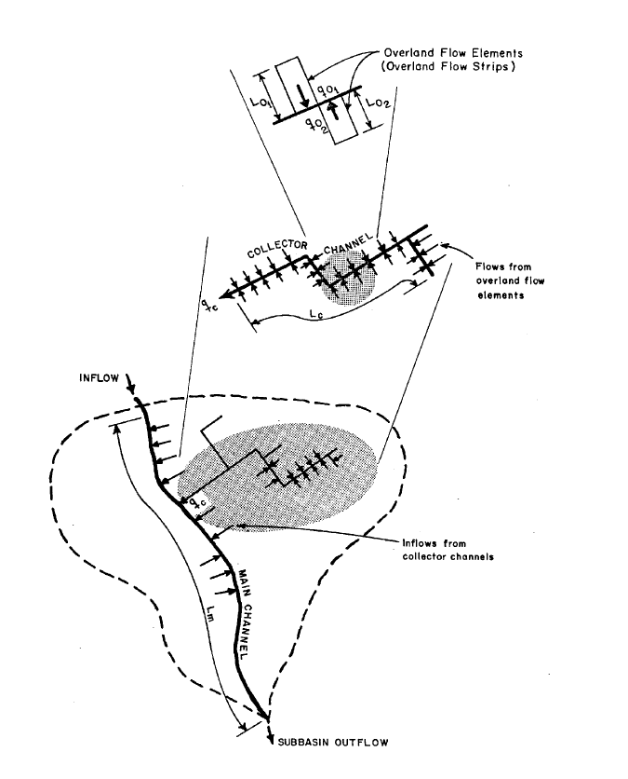

Source: Reference 3.

The overland flow time of concentration may be determined by the following nomograph in Figure 1. A nomograph is a chart usually containing three parallel scales graduated for different variables so that when a straight line connects values of any two, the related value may be read directly from the third at the point intersected by the line. Notice that the units on this nomograph are U.S. customary units and the result should be obtained first in this unit system and converted to SI units because the nomograph is based on the equation shown on it that uses empirical constants developed in this unit system.

Figure 1. Nomograph for Overland Flow Time of Concentration

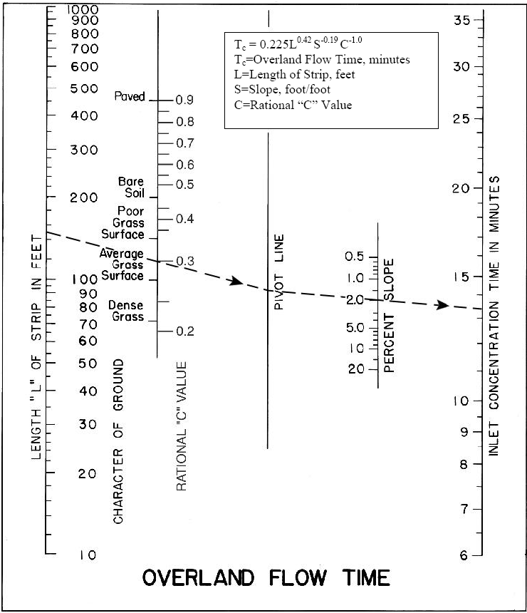

The overland flow time of concentration is determined by drawing a straight line through the flow length of the overland flow and the surface type or rational runoff coefficient and extending this line to the pivot line in the center of the nomograph. A line is then drawn from the intersecting point of the first line and the pivot line through the overland flow slope and extending this line to the concentration time line. Alternately the equation given in the top of Figure 1 can be used to calculate the time of concentration.

Shallow concentrated flow will occur after the maximum length of overland flow; generally within a distance of 100 to 150 meters such as in the depressions on the side of a slope or mountain. The designer should use topographic maps to determine where the shallow concentrated flow will begin and end such as a shallow watercourse. Topographic maps can be obtained from project survey drawings or for areas not within the project limits from Reference 6. The map scale for Afghanistan topographic maps is

1:250,000, and therefore will generally be used in conjunction with a CAD program to enlarge, scale and compute the area from an image file.

Shallow concentrated flow time of concentration is determined by dividing the flow length by the flow velocity. The flow velocity is determined by the following nomograph:

Figure 2. Nomograph for Shallow Concentrated Flow Velocity

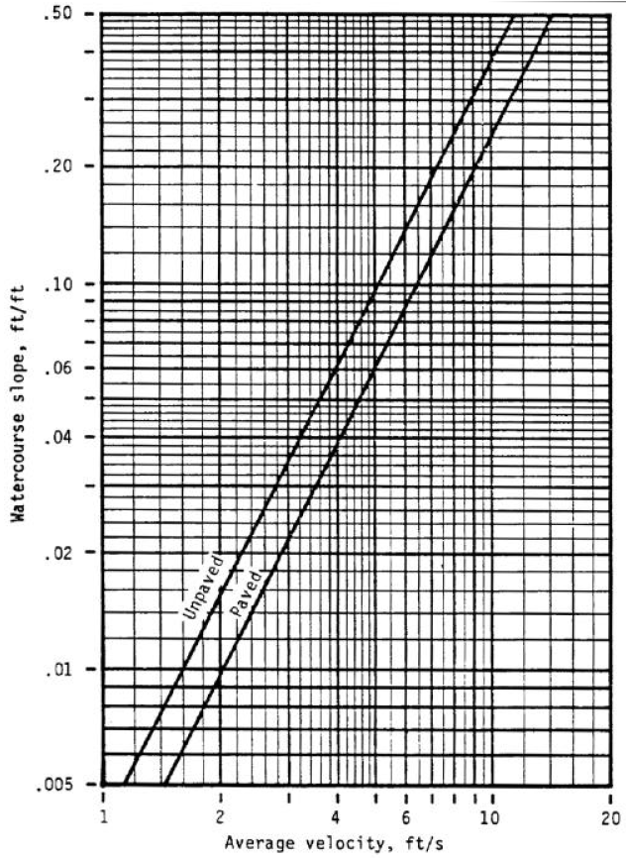

Enter the nomograph using the slope of the shallow concentrated flow path and extend a line horizontally until the diagonal line of the appropriate surface type is intersected. From this point, extend the line straight down to determine the average velocity. The average velocity of the above nomograph is expressed in ft/sec. which is converted to m/min by multiplying by 18.29. The equations for these surfaces are:

Unpaved surface: y = 16.441x0.5063

Paved surface: y = 19.794x0.4896

where

x =slope, ft/ft y=average velocity, ft/s

Channel flow will occur in swales, ditches or underground culverts that have a sufficient volume to adequately convey the flow. Channel flow time of concentration is determined by dividing the flow length by the flow velocity. The channel flow velocity is determined by Manning’s formula as shown below.

V=(1/n)R2/3S1/2

Where

V=flow velocity (m/sec)

n=roughness coefficient

R=hydraulic radius, cross sectional flow area/wetted perimeter (m) S=channel slope (m/m)

Manning’s roughness coefficients (n) for various channel surfaces are provided below in Table

2. Total time of concentration is the sum of the overland and shallow travel time plus the concentrated channel travel time, if any.

**Table 2. Manning's Channel Roughness Coefficient**

Type of Channel andDescription tt.inimum Nom1al

LINED CHANNELS (Selected lmings)

a. Concrete

1. Trowel f nish 0.011 0.013

2. Float finish 0.013 0.015

3. Gunite, good section 0.016 O.Ot 9 b. Asphalt

1. Smooth 0.013 0.013

2. Rough 0.016 O.Ot6

EXCAVATEDOR DREDGED

a.Earth, straight and unifoml

1.Clean, recently completed 0.016 O.Ot 8

2. Clean,after weathering 0.018 0.022

3.Gravel,uniformsection, dean 0.022 0.025

4.With short grass, few weeds 0.022 0.027 b.Earth,winding and sluggish

1.No vegetation 0.023 0.025

**2. Grass, some weeds** 0.025 0.030

3.Dense weeds or aquatic plants in deep channels 0.030 0.035

4.Earth bottomand rubble sides 0.025 0.030

5.Stony bottomand weedy sides 0.025 0.035

6.Cobb e bottom and clean sides 0.030 0.040

c.Dragline excavated or dredged

1.No vegetation 0.025 0.028

2.Light brush on banKs 0.035 0.050 d.Rock cuts

1.Smooth and uniform 0.025 0.035

2.Jagged and irregular 0.035 0.040

e. Channels not maintained,weedsand brush uncut

1.Dense weeds,high as flow depth 0.050 0.080

2. CleanIJottom, brush on sides 0.040 0.050

3.Same, highest stage of flow 0.045 0.070

4.Densebrush, high stage 0.080 0.100

Max rwm

0.015

0.016

0.023

0.020

0.025

0.030

0.033

0.030

0.033

0.040

0.035

0.045

0.050

0.033

0.060

0.040

0.050

0.120

0.080

0.110

0.140

NATURAL STREAMS

1. Minor streams (top width at flood stage <100ft)

a. Streams on Plain

1. Clean, straight, full stage,

no lifts or deep pools 0.025 0.030 0.033

2. Same as above, but more stones/weeds 0.030 0.035 0.040

3. Clean,winding,somepools/shoals 0.033 0.040 0.045

4. Same as above, but some weeds/stones 0.035 0.045 0.050

5. Same as above, lower stages,

more ineffective slopes and sections 0.040 0.048 0.055

6. Same as 4,IJut mae stones 0.045 0.050 0.060

7. Sluggish reaches,weedy,deep pools 0.050 0.070 0.080

8. *Very* weedy reaches,deeppools,or ftoodways with heavy stand of timiJer

and undertJrush 0.075 0.100 0.150 b.MOUi tain streams,no vegetation in channel,

IJanks usually steep,trees and brush along banKs submerged at high stages

|  |  |  |  |  |
| --- | --- | --- | --- | --- |
| 1. | Bottom:gravels, cob!Jies and few | 0.030 | 0.040 | 0.050 |
| 2. | boulders  Bottom: oobbles with large boulders | 0.040 | 0.050 | 0.070 |

2.Floodplains

a. Pasture, no brush

1.Short grass 0.025 0.030 0.035

2.High grass 0.030 0.035 0.050

b. Cultivated area

1.No crop 0.020 0.030 0.040

2.Mature row crops 0.025 0.035 0.045

3.Mature field crops 0.030 0.040 0.050

c. Brush

1.Scattered brush,heavy weeds 0.035 0.050 0.070

2.Light brush and trees,in winter 0.035 0.050 0.060

3.Light IJrushandtrees, insummer 0.040 0.060 0.080

4.Medium to dense brush, inwinter 0.045 0.070 0.t10

5.Medium to dense brush, isummer 0.700 0.100 0.t60

d. Trees

1.Dense Willows,summer,straight O.t10 0.150 0.200

2.aeared land " ithtree stumps,no

sprouts 0.030 0.040 0.050

3. Same as above,but 'ith heavy

growth of sprouts 0.050 0.060 0.080

4.Heavy stand of t mber,a few down

trees, lrttteundergrot·.h,flood stage

IJelow IJranches 0.080 0.100 0.120

5.Same as above, butwithflood stage 0.100 0.120 0.t60

reaching branches

3. Major Streams (top width at flood stage > 100ft)

The n value is less than that for minor streams of similar description, because banKs offer less effective resistance.

|  |  |  |
| --- | --- | --- |
| a. Regular section with no boulders or brush | 0.025 | 0.060 |
| b.Irregular and rough section | 0.035 | 0.tOO |

Several alternative methods are available for estimation of the time of concentration that are based on empirical relationships for specific geographic areas and caution should be exerted in their application to a specific site. For example, another method for overland time of concentration is Kirpich’s formula. It is based on analysis of data for watersheds in the state of Tennessee in the United States and has not been validated for Afghanistan. Note the units are customary US units are used in some of these methods which should be used to provide the results because the formula is based on empirical coefficients derived in that unit system.

**4.2. Soil Conservation Service (SCS) Unit Hydrograph Method**

As the drainage basin size increases, the Rational Method becomes less accurate for a number of reasons. The principal reason is that the underlying concept behind the method, namely that the peak rainfall intensity duration is equal to the time of concentration no longer is a reasonable assumption. The water courses in larger basins have flood plains that will reduce larger flood flow rates because they will store flood water in their overbank areas thereby reducing the peak discharge rate. Large basins have more varied topography which correlates to varying times of concentration. Because of these and other limitations, numerous methods for developing unit hydrographs for selected watersheds have developed. **The Rational Method may significantly overestimate the peak discharge rate for larger basins and therefore the limit of 1 square kilometer for it has evolved from engineering experience as a useful upper limit.**

A unit hydrograph is defined as the direct runoff hydrograph (flow rate versus time relationship) from one unit of excess rainfall (usually 1 cm in SI units) generated uniformly over the drainage area at a constant rate for an effective duration of time. References 2 and 3 provide information on the theory and calculation details.

Because the solution to the total hydrograph computation involves successive convolutions of unit hydrographs for the period of the storm, the method is suitable to the use of computer programs for execution. Several programs are available from US Government agencies that are based on a particular unit hydrograph shape known as the SCS unit dimensionless hydrograph; reference 3 shows the location for one such program HEC-1 Flood hydrograph package. This program allows the user to employ the SCS unit hydrograph method with a hypothetical rainfall pattern constructed from data obtained from the intensity-duration- frequency curves (previously described in the rational method) to compute runoff hydrographs. In order to simplify the use of the SCS method for drainage areas in the range of one to two square kilometers which are common on road projects in Afghanistan, graphs have been prepared of peak discharge and runoff volumes have been computed for use shown in Figure 3. Results for other basins sizes can be obtained by the ratio of the drainage areas multiplied times the values from the figure. For large basins (greater than 10 sq km) a factor shown in Appendix C may be applicable.

Figure 3. SCS Unit Hydrograph Results for 1 Sq Km Drainage Area

**SCS Unit Hydrograph Runoff Results For 1 Sq Km**

8

7

6

**Peak 10‐year Flood Flow, cms**

CN = 95 & RUNOFF = 75% of RAINFALL

5

CN = 95 & RUNOFF = 20% of RAINFALL

4

3 CN = 85 & RUNOFF = 40% of RAINFALL

2

CN = 75 & RUNOFF = 20% of RAINFALL

1

0

0.5 0.7 0.9 1.1 1.3 1.5 1.7

**Basin Lag Time, hours**

Peak, cms Peak, cms

Caution should be used applying data in Figure 3 for basins greater than two square kilometers in size because the floodplain attenuation effects in larger watersheds are neglected. Use of the curves requires calculating the basin lag defined as 0.6 times the time of concentration and the approximate runoff ratio based on the rational method or from data to develop curve numbers described below. For basins larger than 2 square kilometers or other flood frequency (than 10-year) storms, the design should be based on calculating the runoff using a computer model that supports the SCS method. If more than one basin analysis is required, a computer model should be used to perform hydrologic routing of the individual basins; Figure 3 curves do not include these affects and should not be used to combine more than one basin results.

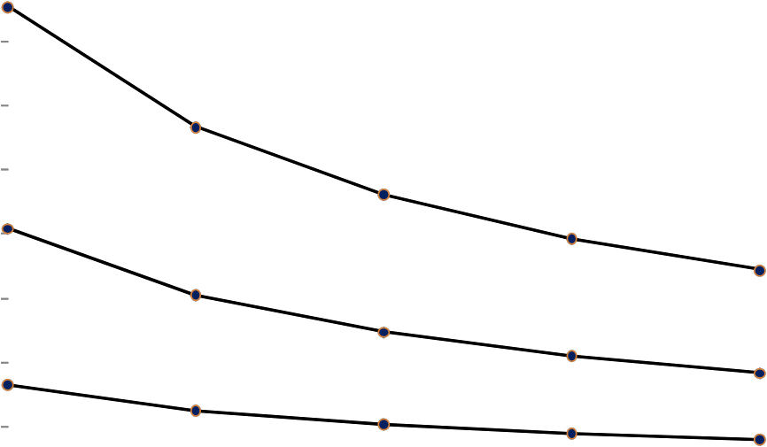

The SCS unit hydrograph technique is described in reference 2. There are two basic parameters required to use this method: basin lag and basin runoff curve number (CN) value. Basin lag is defined by the method as approximately 0.6 times the time of concentration (previously described in the rational method). The curve number is a dimensionless number that is an empirical function of soils slope, and land cover. It is used in the SCS method to determine the amount of rainfall retention over time that the watershed can hold. The excess becomes runoff. The curve numbers were derived empirically for non urban areas in the United States following a long program of collecting measurements at Soil Conservation Service hydrologic field stations of stream flow, precipitation, land cover and soil moisture. Tables of CN values for different hydrologic soil groups and land use are published in several sources.

Soil types are defined as follows:

Group A: deep sands, deep loess, aggregated silts

Group B: shallow loess, sandy loam

Group C: clay loams, shallow sandy loams, and soils high in clay

Group D: soils that swell when wet, plastic clays, and certain saline soils

Soil classification is defined in the SCS soil classification textural triangle shown in Figure 4. The availability of soil classification in regions of Afghanistan can be determined using internet sources (see References 5 and 6). Surface soil classification from geotechnical reports for project foundation design can also be used as a source of soil information provided the top soil horizon is used for determination of the runoff curve number.

Figure 4. SCS Soil Classification for Soil Groups

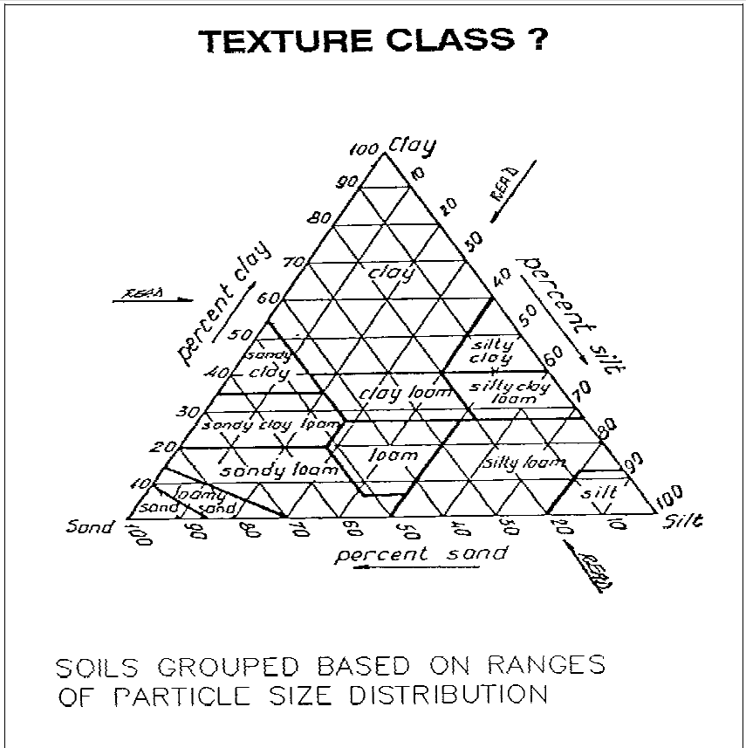

The simplicity of the SCS hydrograph method makes it a good choice for large catchment hydrologic evaluations in Afghanistan where hydrologic data is meager or non-existent and the most likely information available is geology, soils, and some aerial information that indicates the type of land cover. The critical parameter to estimate is the SCS curve number (CN) value. Using the CN parameter value, and the overall catchment slope that can be obtained from aerial imagery programs available on the internet, the designer can estimate the basin lag and time of concentration, the second parameter required for the method application. The CN value determination is discussed next.

Curve Number Determination

Depending upon the scale of the drainage area that is required in the design analysis under study, the curve number may be determined using different procedures.

Project site scale – this is a drainage area that basically encompasses only the project site as defined by the scope of work. In this case information will normally be available from the geotechnical report to relate two laboratory measures parameters: bulk density and textural classification, to saturated hydraulic conductivity, which is can be related to the CN value to use as will be shown by example in this manual.

Regional scale – this is a drainage area that encompasses a large area offsite of the project site such as a large wadi or river draining through the project construction site or a bridge / culvert location beneath a road project alignment. For this hydrologic scale, detailed soil information is not available and the soil types shall be based on project site soils, regional geologic map classification of alluvium, field observations, and one of the agricultural soil surveys that may have been made by agencies such as FAO. An example of a large regional analysis is shown in Attachment D.

Note that there are limits to the size of the watershed that should be modeled by a single unit hydrograph. Subbasins should be delineated for portins of the watershed with different hydrologic characteristics. In addition the two models used by the NRCS have different limits. In the WinTR55 computer program the total watershed size is limited to 65 square kilometers (about 25 square miles). However, WinTR20 can be used for larger watersheds. Multiple subbasins can be combined and routed downstream and combined further with other subbasins if large basins using hydrologic routing methods described in most hydrologic engineering references. An example in Attachment D shows this procedure. In general, the SCS unit hydrograph method should not be applied to a single basin larger than 250 square kilometers; and the basin lag equation given above is only valid for time of concentration less than 10 hours which should be used to limit the size of the subbasins in a watershed model. Other factors that should be considered to determine subbasin delineation include: 1) confluences of major wadi or rivers, 2) change in topographic or land cover conditions between areas that affect the hydrology, and 3) locations where structures such as barrages or bridges may affect the hydrologic routing of floods.

Field and laboratory results from the geotechnical field investigations for the upper one meter of the soil profile at the site shall be used to obtain the USCS soil classification, including the

fraction of the major particle sizes, and the soil bulk density. Based on the definition of the hydrologic soil groups below, the **natural** site soil shall be classified as one of four SCS hydrologic soil groups as follows:

Type A soils have less than 10% fines (clay/silt) and more than 90% sand or gravel; the depth to any impermeable layer is greater than 500 mm; saturated hydraulic conductivity is greater than

14.4 centimeter/hour (5.67 inch/hour). These soils have sandy or gravelly textures.

Type B soils have 10% to 20% fines (clay/silt) and between 50% to 90% sand or gravel; the depth to any impermeable layer is greater than 500 mm; saturated hydraulic conductivity in the least permeable layer is between 3.6 to 14.4 centimeter/hour (1.42 to 5.67 inch/hour). These soils have loamy sand or sandy loam textures.

Type C soils have 20% to 40% fines (clay/silt) and less than 50% sand or gravel; the depth to any impermeable layer is greater than 500 mm; saturated hydraulic conductivity in the least permeable layer is between 0.36 to 3.6 centimeter/hour (0.142 to 1.42 inch/hour). These soils have silty loam or sandy clay loam textures.

Type D soils have more than 40% fines (clay/silt) and less than 50 % sand; saturated hydraulic conductivity in the least permeable layer is less than 0.36 centimeter/hour (0.142 inch/hour). These soils have clayey textures.

Disturbed soils as a result of construction and other disturbances such as some agricultural practices like paddy construction have soil profiles that are altered from their natural state and the listed group assignments generally no longer apply. This would apply to project sites that were graded, filled and compacted either unintentionally with vehicles during construction or intentionally using compaction equipment. In consideration of this fact, the hydrologic soil group (and indirectly the CN value) assigned to a watershed will be adjusted for the expected change in saturated hydraulic conductivity as explained using the chart shown in Figure 5. The chart in this figure is used for field classification of soils by the NRCS.

Figure 5 Saturated hydraulic conductivity based on soil properties (see explanation notes on following page)

Medium Density

- Sand Separate,%---

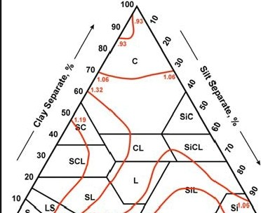

Low Density

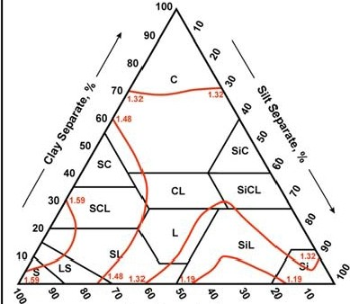

*L-_a---- ----*

- Sand Separate,%---

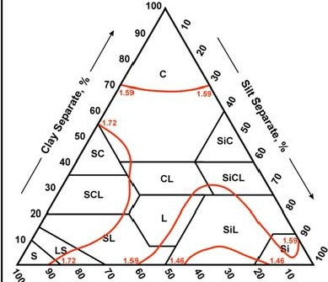

High Density

- Sand Separate,%---

Ksat for Medium Bulk Density

- Sand Separate,%---

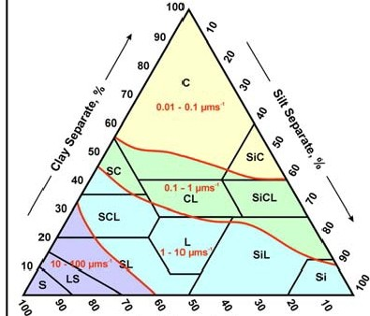

Ksat for Low Bulk Density

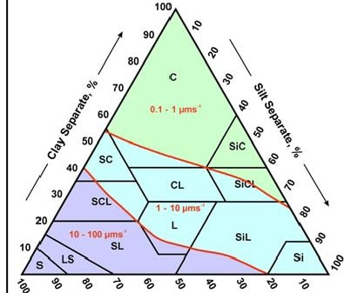

- Sand Separate,%---

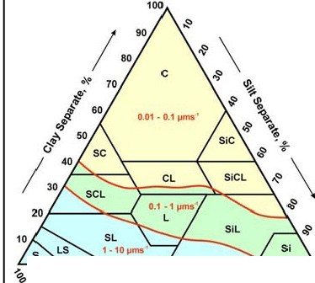

Ksat for High Bulk Density

*L- -- ---- ------*

'&

- Sand Separate,%---

Explanation notes:

1. This chart is obtained from the National Resources Conservation Service (formerly SCS) National Soil Survey Handbook Part 618 Exhibit 618-9, Guide for estimating Ksat from soil properties.

2. Using the soil gradation classes and bulk density from the bulk density test (ASTM D

1556) found in the project geotechnical report to calculate an average values for the site (or zones within the site if soil classification varies), to find the point in the textural triangle on the left side of the figure above corresponding to the calculated bulk density. Bulk density on the chart is expressed in units of grams/cubic centimeter. Note the NRCS soil classifications shown on the triangles are not identical to the USCS classification; so use the percentage from the gradation analysis.

3. Find the same point location on the textural triangle on the right side of the figure above that corresponds to the location in the triangle on the left side; read the estimated range of saturated hydraulic conductivity from the right side triangle. The units of saturated hydraulic conductivity are micrometers per second. Multiply the range of the estimating Ksat from the triangle times 0.36 to convert to centimeters/hour.

4. Use the estimated Ksat obtained above to determine from the four soil class definitions the appropriate soil type (A, B, C, or D). If the top 0.5 meter of the final graded soil is to remain relatively undisturbed (only foot traffic and hand graded) use the largest value in the range for Ksat but if the site is mass graded with construction equipment or compacted using equipment, use the lowest value in the range to determine the hydrologic soil group class.

5. Example: An example in Appendix D showsthe use of the lab results to determine the hydrologic soil type class

The CN value depends upon factors such as the intensity of the rainfall relative to the hydraulic conductivity, land cover, slope and treatment (such as agricultural practices). The relationships have been considered in the reparation of tables of recommended values. After the hydrologic soil group is chosen, a selection of CN values for USACE-AEN projects can be made from Table

3 which is summarized from various sources noted.

Table 3 Selected1 SCS Curve Numbers for USACE-AEN project by hydrologic soil groups. Shaded rows shall not be used without aerial photographic documentation.

|  |  |  |  |  |  |
| --- | --- | --- | --- | --- | --- |
| **Land Use** | **Hydrologic**  **Condition2** | **Hydrologic Soil Group** | | | |
| **A** | **B** | **C** | **D** |
| Bare Soil | newly  graded - no vegetation | 77 | 86 | 91 | 94 |
| Desert shrub | Poor | 63 | 77 | 85 | 88 |
| Fair | 55 | 72 | 81 | 86 |
| Good | 49 | 68 | 79 | 84 |
| Paddy land | AMC3 I |  |  | 67 |  |
| AMC II |  |  | 82 |  |
| AMC II |  |  | 91 |  |
| Dry land Ag  Pasture , grassland or range land for grazing | Poor | 68 | 79 | 86 | 89 |
| Fair | 49 | 69 | 79 | 84 |
| Good | 39 | 61 | 74 | 80 |
| Wooded –  brush lands such as in mountainous areas | Poor | 57 | 73 | 82 | 86 |
| Fair | 43 | 65 | 76 | 77 |
| Good | 32 | 58 | 72 | 73 |
| Roads  (including shoulders) | Dirt  Gravel | 72 | 82 | 87 | 89 |
| 76 | 85 | 89 | 91 |

Notes:

1. References: Natural Resources Conservation Service National Engineering Handbook Part

630 Chapter 9 Hydrologic Soil-Cover Complexes, 2004; *Application of SCS Curve Number Method for Irrigated Paddy Field*, KSCE Journal of Civil Engineering, 2007; Washington Department of Ecology, Storm Water Management Manual for Eastern Washington, 2004

2. Poor: less than 30% ground cover (shrub plants, grasses), and bare soil

Fair: 30 to 70% ground cover over land surface

Good: more than 70% ground cover over land surface

3. AMC – previous 5-day total antecedent rainfall (antecedent moisture condition) I – less than 1.27 cm

II – 1.27 to 2.79 cm

III – over 2.79 cm

4. Impervious surface (paved roads, buildings, parking areas) CN= 98 all soil groups

5. Good cover conditions are nearly none-existent and shall not be assumed unless documented by photographic evidence

CN values shall not be based on references that rely on clearly different land cover or vague descriptions of the percent impervious cover. Examples such as “medium density townhouse development” or “1/4 acre residential lots” are not applicable to the projects covered by this design requirements manual. CN values shall also reflect the impervious cover by either assigning that portion of the drainage basin a value of 98 for impervious cover (paved rods, building, concrete walks and parking, etc.) or indicating in the hydrologic model input the percentage of the total area represented by a particular CN is considered impervious.

Basin Lag Calculation

The basin lag may be calculated from the following empirical relationship1:

Tb = (L0.8 x ((1000/(CN-10))+1)0.7)/(1900* Y0.5)

Where Tb = basin lag, hours defined as the time from the center of rainfall excess mass to the peak discharge in the watershed.

L = hydraulic length of the watershed, feet

CN = SCS curve number

Y= the slope in percent

Note that the US customary units must be used in this equation

Note the basin lag is shorter than the time-of concentration defined as the time for water to travel from the most hydrologically distant part of the watershed to the point of design interest. The two parameters are approximately related by the following equation2:

Tc = 1.67 x Tb

Where Tc = the time of concentration; this is the time parameter used in the rational method

Software

There are at least two public domain software packages that designers can download without cost to obtain an executable program file, user manual and example files from the internet:

1. USACE HEC-1: Flood Hydrograph Package, 1998 <http://www.hec.usace.army.mil/software/legacysoftware/hec1/hec1.htm>

In addition to the program and user manual, the following documents also available at this site may be useful:

TD32- Using HEC-1 on a personal computer

COED – text editor that aligns the input file in columns required for HEC-1

2. NRCS WinTR55: Small Watershed Hydrology, 2009 [http://www.wsi.nrcs.usda.gov/products/w2q/h&h/tools_models/wintr55.html](http://www.wsi.nrcs.usda.gov/products/w2q/h%26h/tools_models/wintr55.html)

1 *A Guide to Hydrologic Analysis Using SCS Methods*, Richard McCuen, Prentice Hall, 1982, Chapter 7, Estimating the Time of Concentration, p.19

2 *Applied Hydrology*, Ven Te Chow, David Maidment, and Larry Mays, McGraw Hill, 1988, p. 229

or for watershed larger than 65 square kilometers the following model may be used: NRCS WinTR20: Computer Program for Project Formulation Hydrology [http://www.wsi.nrcs.usda.gov/products/W2Q/H&H/Tools_Models/WinTR20.html](http://www.wsi.nrcs.usda.gov/products/W2Q/H%26H/Tools_Models/WinTR20.html)

Either program can be used by designers to conduct hydrologic analysis using the SCS unit hydrograph method using the parameters described previously in this section. Probably the easiest to use is the WinTR55 program, but it is limited to 65 sq km total basin size and will not run for total basin area greater than this size. WinTR20 can be used instead which is the same methodology but the input is not in the same format. Both use a Windows menu format for input that will simplify input processing and reduce input errors. Input for each subbasin consists of area, CN value, and basin lag. Channel reach characteristics include length, slope, bottom width, side slope and Manning’s roughness value. Both the WinTR55/20 and HEC-1 programs require rainfall depth duration information; but there are differences in the type of this information between the two programs that will be discussed subsequently.

HEC-1 does not use a Windows menu input processor; although economical ones can be purchased for it. The COED program that can be downloaded with the model is a public domain program that can be used to prepare the input in the correct fields. Users can also purchase proprietary programs such as RGMHEC2000 HEC-1 Interactive Graphical Interface (http://www.hec1.com). It is recommended for first time users to edit an existing input file obtained from examples in the software download for using this program such as the input file provided in the example in Attachment D. Input for each subbasin consists of area, CN value, and basin lag. Channel reach characteristics include length, slope, bottom width, side slope and Manning’s roughness value. Several types of rainfall patterns can be input into HEC-1, but the easiest is to use the alternating block method described in the user manual. It is based on converting the rainfall intensity duration frequency (IDF) for the design storm found in the charts in this AED design requirements manual into total rainfall depths for various durations identified in the input description. The shortest duration has the greatest depth which is assumed to be the center of the storm hyetograph. Subsequent durations are placed on either side of this center by the program. This method also produces a design storm rainfall pattern that is unique to the region where the project is located because the IDF is unique to the region.

Both WinTR55/20 are provided with dimensionless rainfall depth-duration relationships. These programs use the SCS standard 24-hour rainfall cumulative depth-duration distribution patterns for the United States. These dimensionless depth-duration patterns, however, are not representative of the type of relatively short intensity storms that produce severe floods at USACE-AEN projects in the summer and fall seasons. For example the SCS Type I storm distribution pattern is based on relatively long-duration (several days) storm associated with large marine frontal systems over the western U.S. In contrast, relatively short duration storms associated with atmospheric convection systems are more likely in Afghanistan in the summer and early fall when the influence of the monsoon from the Indian sub-continent is present, particularly in the eastern part off the country. There is no reason to believe the SCS dimensionless rainfall depth-duration relationships for the US apply to Afghanistan.

A comparison of the two methods – a ten-year storm based on the HEC-1 alternating block hyetograph developed using the IDF curves for Gardez versus a 10-year, 24-hour storm depth based on the SCS Type I 24-hour dimensionless storm – indicated the flood peak from the SCS dimensionless storm was only 60% of the flood peak based on the HEC-1 method. All other factors were the same. The difference is attributed to the intensity of the storm predicted from the 24-hour dimensionless curves which results in short duration intensities that are not as severe as the regional IDF rainfall intensity duration data indicate is possible. As a result of this difference, the SCS storm distribution relationships (e.g. Type I or Type II) should not be used for flood hydrograph analysis.

An AEN Type II modified dimensionless rainfall distribution curve was prepared to preserve the rainfall depths corresponding to short precipitation duration shown in the intensity duration frequency curves in Appendix B. The SCS 24-hour Type II curve was modified to obtain the following rations of rainfall depth (for each duration) to the total 24-hour depth:

|  |  |  |  |
| --- | --- | --- | --- |
| Duration of  precipitation, minutes | 15 | 30 | 60 |
| Ratio of precipitation  for indicated duration to 24-hour storm total | 0.271 | 0.417 | 0.476 |

The modified AEN Type II dimensionless storm distribution data points are shown in Table 4. These may be entered in either TR20 or TR 55 using the customized rainfall distribution input option.

An example application using both HEC-1 and WinTR20 is shown in Attachment D. In this example a large (137 sq km) catchment is analyzed to determine the peak flow for the ten-year storm at a point where a road project crosses a wide wadi. A multivent culvert or bridge must be designed for the design storm peak flow rate. The example shows how regional geology and aerial imagery are used to determine a curve number for each subbasin. The CN value is used in the example along with basin characteristics obtained from the aerial imagery to determined basin lag or time of concentration. These are the basic input parameters for the SCS unit hydrograph method. The model routing schematic for each program is shown in the example. The outflow hydrographs for each subbasin and the point of interest are shown and the magnitude of the peak flows compared.

Table 4 Dimensionless Rainfall-Depth-Duration for Use in WinTR55 or WinTR20

Type AENTypeIIm1 .10042

|  |  |  |  |  |
| --- | --- | --- | --- | --- |
| 0.00000 | 0.00100 | 0.00200 | 0.00300 | 0.00410 |
| 0.00510 | 0.00620 | 0.00720 | 0.00830 | 0.00940 |
| 0.01050 | 0.01160 | 0.01270 | 0.01380 | 0.01500 |
| 0.01610 | 0.01730 | 0.01840 | 0.01960 | 0.02080 |
| 0.02200 | 0.02320 | 0.02440 | 0.02570 | 0.02690 |
| 0.02810 | 0.02940 | 0.03060 | 0.03190 | 0.03320 |
| 0.03450 | 0.03580 | 0.03710 | 0.03840 | 0.03980 |
| 0.04110 | 0.04250 | 0.04390 | 0.04520 | 0.04660 |
| 0.04800 | 0.04940 | 0.05080 | 0.05230 | 0.05380 |
| 0.05530 | 0.05680 | 0.05830 | 0.05980 | 0.06140 |
| 0.06300 | 0.06460 | 0.06620 | 0.06790 | 0.06960 |
| 0.07120 | 0.07300 | 0.07470 | 0.07640 | 0.07820 |
| 0.08000 | 0.08180 | 0.08360 | 0.08550 | 0.08740 |
| 0.08920 | 0.09120 | 0.09310 | 0.09500 | 0.09700 |
| 0.09900 | 0.10100 | 0.10300 | 0.10510 | 0.10720 |
| 0.10930 | 0.11140 | 0.11350 | 0.11560 | 0.11780 |
| 0.12000 | 0.12220 | 0.12460 | 0.12700 | 0.12960 |
| 0.13220 | 0.13500 | 0.13790 | 0.14080 | 0.14380 |
| 0.14700 | 0.15020 | 0.15340 | 0.15660 | 0.15980 |
| 0.16300 | 0.16630 | 0.16970 | 0.17330 | 0.17710 |
| 0.18100 | 0.18510 | 0.18950 | 0.19410 | 0.19890 |
| 0.20400 | 0.20940 | 0.21520 | 0.22140 | 0.22800 |
| 0.23500 | 0.24270 | 0.25130 | 0.26090 | 0.27150 |
| 0.28300 | 0.30680 | 0.35440 | 0.43080 | 0.56790 |
| 0.70200 | 0.71200 | 0.72860 | 0.73700 | 0.74520 |
| 0.75300 | 0.75940 | 0.76540 | 0.77080 | 0.77560 |
| 0.78000 | 0.78400 | 0.78800 | 0.79200 | 0.79600 |
| 0.79980 | 0.80320 | 0.80780 | 0.81220 | 0.81620 |
| 0.82000 | 0.82370 | 0.82730 | 0.83080 | 0.83420 |
| 0.83760 | 0.84420 | 0.84740 | 0.85050 | 0.85350 |
| 0.85650 | 0.85940 | 0.86220 | 0.86490 | 0.86760 |
| 0.87020 | 0.87280 | 0.87530 | 0.87770 | 0.88000 |
| 0.88230 | 0.88450 | 0.88680 | 0.88900 | 0.89120 |
| 0.89340 | 0.89550 | 0.89760 | 0.89970 | 0.90180 |
| 0.90380 | 0.90580 | 0.90780 | 0.90970 | 0.91170 |
| 0.91360 | 0.91550 | 0.91730 | 0.91920 | 0.92100 |
| 0.92280 | 0.92450 | 0.92630 | 0.92800 | 0.92970 |
| 0.93130 | 0.93300 | 0.93460 | 0.93620 | 0.93770 |
| 0.93930 | 0.94080 | 0.94230 | 0.94380 | 0.94520 |
| 0.94660 | 0.94800 | 0.94930 | 0.95070 | 0.95200 |
| 0.95330 | 0.95460 | 0.95590 | 0.95720 | 0.95840 |
| 0.95970 | 0.96100 | 0.96220 | 0.96350 | 0.96470 |
| 0.96600 | 0.96720 | 0.96850 | 0.96970 | 0.97090 |
| 0.97220 | 0.97340 | 0.97460 | 0.97580 | 0.97700 |
| 0.97820 | 0.97940 | 0.98060 | 0.98180 | 0.98290 |
| 0.98410 | 0.98530 | 0.98640 | 0.98760 | 0.98870 |
| 0.98990 | 0.99100 | 0.99220 | 0.99330 | 0.99440 |
| 0.99560 | 0.99670 | 0.99780 | 0.99890 | 1.00000 |

Table 4 contains the dimensionless fraction of the storm at successive time intervals during the total 24-hour storm duration; values are read from left to right from 0.0000 to 1.0000. The time interval is indentified at the top in hours (0.10042) or six minutes. The graph below shows the overall shape of the dimensionless storm pattern. These data were obtained from the Win TR *55* program.

WinTR-ss custom R int ll Distribution 2 1li2011

CI:Doct•nents and Settings\Jim'.AjlpllcatkM\ Data'cWlnTR-551R;oinfaiiDist,.ibtllions'AEIITypellrnoll.tbl

new file

1.0

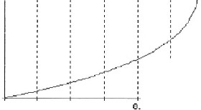

.ll

.8

M .7

A

s

s .6

R

A .5

I

N

F .4

A

L

L .3

.2

.1 .

---- MASS RA INFALL

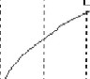

.0

2. 4. 6.

10. 12. 14.

T I ME (hr>)

10. 18. 20. 22. 24.

**5. Design Submittal Documentation**

Design analysis reports shall summarize the results of the calculations in a tabular form. The contents of the table shall include the following information:

Rational Method:

• basin name/ or culvert number

• drainage area

• calculated time of concentration

• rainfall intensity for design storm

• runoff coefficient in rational method for the basin

• reduction for total area factor

• peak flow rate at the point of concentration (for structure design) SCS Unit Hydrograph Method

• basin name/ or culvert number

• drainage area

• calculated time of concentration or basin lag time

• rainfall distribution and total depth for design storm

• curve number and method for their estimation for each subbasin basin

• channel characteristics assumed and routing method

• routing schematic showing the subbasins and channel routing assumed

• reduction for total area factor

• peak flow rate at each point of interest (for structure design)

Submittal shall include drawings or sketches that identify the catchments areas used in the calculations.

**6. References**

1. UFC 3 230 17FA Drainage for Areas Other than Airfields. Department of Defense, January 2004.

2. U.S. Army Corps of Engineers. Engineering and Design Flood hydrograph Analysis, EM

110-2-1417, August 1994. Found at <http://140.194.76.129/publications/eng-manuals/em1110-2-1417/toc.htm>

3. U.S. Army Corps of Engineers, Hydrologic Engineering Center, HEC-1 Flood Hydrograph Package. 1998. Found at <http://www.hec.usace.army.mil/software/legacysoftware/hec1/hec1.htm>

4. U.S. Army Corps of Engineers, Hydrologic Engineering Center, Flood Frequency

Analysis (FFA) Program. 1994.

5. European Commission Land Management & Natural Hazards Unit. Found at <http://eusoils.jrc.ec.europa.eu/result.cfm?form.criteria=afghanistan%20and%20soil>

6. US Geological Survey Open-File Report 2005-1103 Series of topographic maps found at <http://pubs.usgs.gov/of/2005/>

7. Civil Engineering Reference Manual, Michael Lindenburg, Profesional Publications, Inc.

2008

8. Washington State Department of Transportation, Hydraulics Manual, March 2005. Found at

<http://www.wsdot.wa.gov/Design/Hydraulics/>

9. UFC 3 230 15FA Surface Drainage Facilities for Airfields and Heliports. Department of

Defense, January 2004.